ProtoTract Tool

Using ArcPy

Create a tool that does the following:

1. All input feature polygons should be non-dissolved buffered geologic features, or geologic unit polygons, or polygons representing geochemical or geophysical anomalies of interest, etc.  The main point is, these should files should not be dissolved prior to inputting them into the tool.

 1) Analysis Tools / Overlay / Union...  union all input features. Use default union tool settings.

 2) Data Management / Features / Multipart to Singlepart...  the above union outputs multipart features, rather than singlepart features.  Singlepart features work better for the subsequent aggregation and smoothing operations below.  So, convert multipart features to singlepart. Use default multipart to singlepart tool settings.

 3) Cartography Tools / Generalization / Aggregate Polygons...  Allow the user to specify all parameters, such as aggregation distance, minimum area, minimum hole size, and optionally preserve orthogonal shape and use barriers.

 4) Cartography Tools / Generalization / Simplify Polygon...  Allow the user to specify all parameters. Use defaults

 5) Cartography Tools / Generalization / Smooth Polygon...  Allow the user to specify all parameters. Use defaults.

 6) Analysis Tools / Proximity / Buffer...  Allow the user to optionally add (or not) a buffer of some specificed distance to the output from the process #5 above.  Not sure if the "dissolve" option is the best, as this may result in losing 'holes' polygons from the aggregate polygons process #3 above.  Maybe test this option, or just make it available to the user along with all the other input parameters for the buffer tool.

7) To delete small holes in tract polygons…  Data Management Tools / Generalization / Eliminate Polygon Part:  “Creates a new output feature class containing the features from the input polygons with some parts or holes of a specified size deleted.”

Initial Permissive Tracts

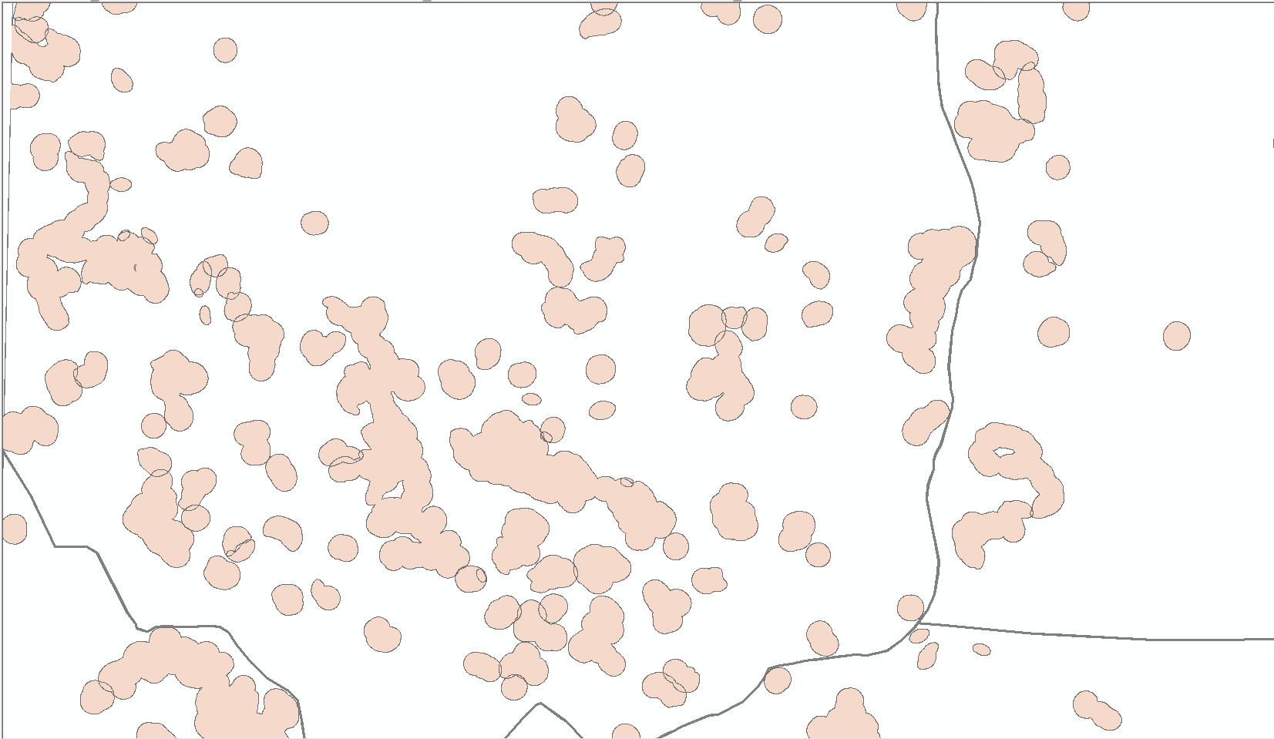

ProtoTract Permissive Tracts

